Historical Events Analysis Paper (Individual)

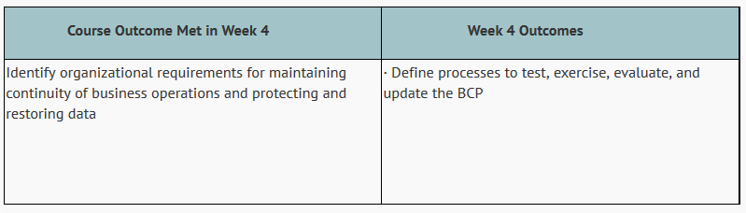
The purpose of this written assignment is to analyze a historical event from the perspective of its impact on an organization and its systems for continuity of business processes. This assignment focuses on business continuity planning and the ability to recover from unforeseen circumstances.
You are to research a major event that not only influenced but transformed how businesses prepared for the unexpected. Select an organization—business, industry, government or major nonprofit—to research and analyze preparation and response to a recent event (Less than 3 years).
IMPORTANT: Please select an organization (just one) that has been impacted by the major event that you are citing. It may be that this organization does not have a BC/DR process or plan – or it could be that this organization has been able to successfully navigate through the event because of being better prepared.
This assignment is designed to increase your knowledge of how systems contribute to contingency planning and disaster recovery and enables you to analyze risk and organizational readiness. This assignment will help you enhance your research and writing skills as well as your critical-thinking abilities. Your analysis should address the requirements below.
You must research a topic of historical significance and analyze its importance from a business contingency planning perspective. You are to discuss the organization and its business processes, summarize the historical event, analyze the event's impacts on systems and the business processes that were required to continue, and explore basic strategies employed to safeguard systems.
You are to provide a three- to five-page (not including cover page and reference page) paper (double-spaced) and submit it in your appropriate Assignments folder on or before its due date. A minimum of four resources, of which at least two must be academically credible sources, must be used. You may not use Wikipedia or undated and/or un-authored (author unknown) sources.
Indicate appropriate APA reference citations for all sources. In addition to critical thinking and analysis skills, your written analysis should reflect appropriate grammar and spelling, good organization, and proper business-writing style.
Assignment Considerations:
- Provide a well-defined and analyzed topic of historical significance from a business contingency planning perspective.
- Discuss its organization and its business processes and how these influenced whether the organization was prepared for the unexpected.
- Provide an impact analysis on systems and business processes required for the business to continue operations.
Grading Rubric:
The following grading rubric applies:
